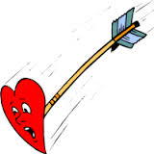

Valentine,

You’ve left a

MARK

On My

HEART!

Love,

Valentine,

You’ve left a

MARK

On My

HEART!

Love,

Valentine,

You’ve left a

MARK

On My

HEART!

Love,

Valentine,

You’ve left a

MARK

On My

HEART!

Love,

Valentine,

You’ve left a

MARK

On My

HEART!

Love,

Valentine,

You’ve left a

MARK

On My

HEART!

Love,